1. Arduino supported
2. Board also supports os just like raspberry pi:

Os used: Intel® IoT Developer Kit version of the Yocto*-built Linux image.

For more info visit: <https://software.intel.com/en-us/get-started-galileo-windows-step1>

So sd card is used to store your programs even after power has been removed

The os on sd card boots when power has been supplied to the board

The os cant be viewed on screen

1. There is a ftdi port also on the board which is used to connect the board to ur computer

Like for eg:

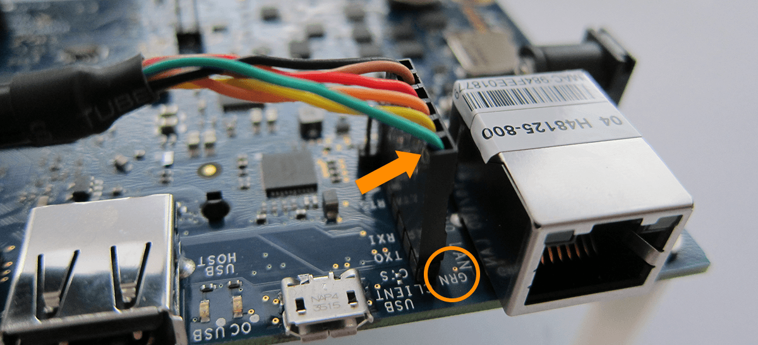

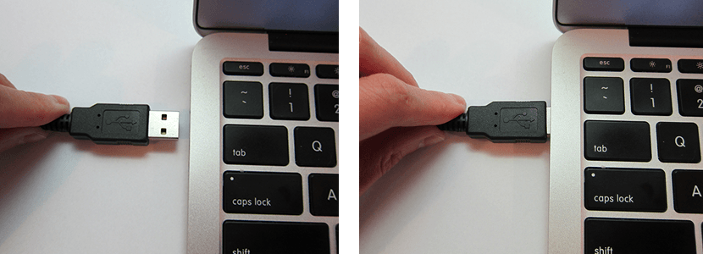

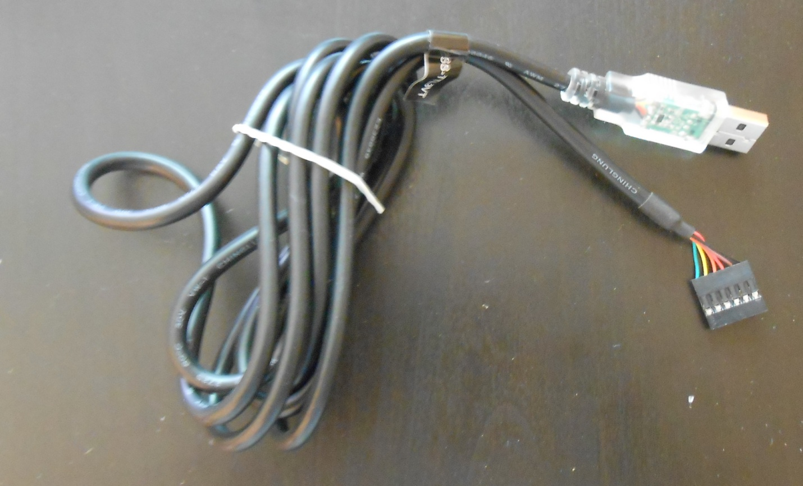

The sd card image can be tested on ur computer just like in case of raspberry pi

Using putty

<https://software.intel.com/en-us/get-started-galileo-windows-step3>

1. Intel Galileo gen 2 supports following languages:

Arduino

Javascript and Node.js

C++

Java

1. The board also supports Ethernet connection

<https://software.intel.com/en-us/articles/intel-galileo-getting-started-ethernet>

ETHERNET ON INTEL GALILEO GEN 2 DONE!!!!!!!!

As indicated in the link above it does not happen that way

A cmd prompt is not generated at arduino atleast

Instead all the commands mentioned in the link are uploaded to the board using function system() through the code

Commands:

1. ifconfig(similar to ipconfig in windows………………. Rpi also supports ifconfig)
2. ifup eth0

changes made in the code:

1. change the mac address to byte mac[] = { 0x98, 0x4F, 0xEE, 0x05, 0x38, 0x01 };
2. this is the mac address of my intel Galileo Ethernet shield
3. add system("ifup eth0");
4. and add
5. IPAddress my=Ethernet.localIP();
6. Serial.println(my);
7. This gives ip address of my board
8. We can ping the board using cmd prompt using the cmd: ping “……………….address in my………….”
9. Also we can create a webserver using the code in the included file and then open the ip address provided in the chrome

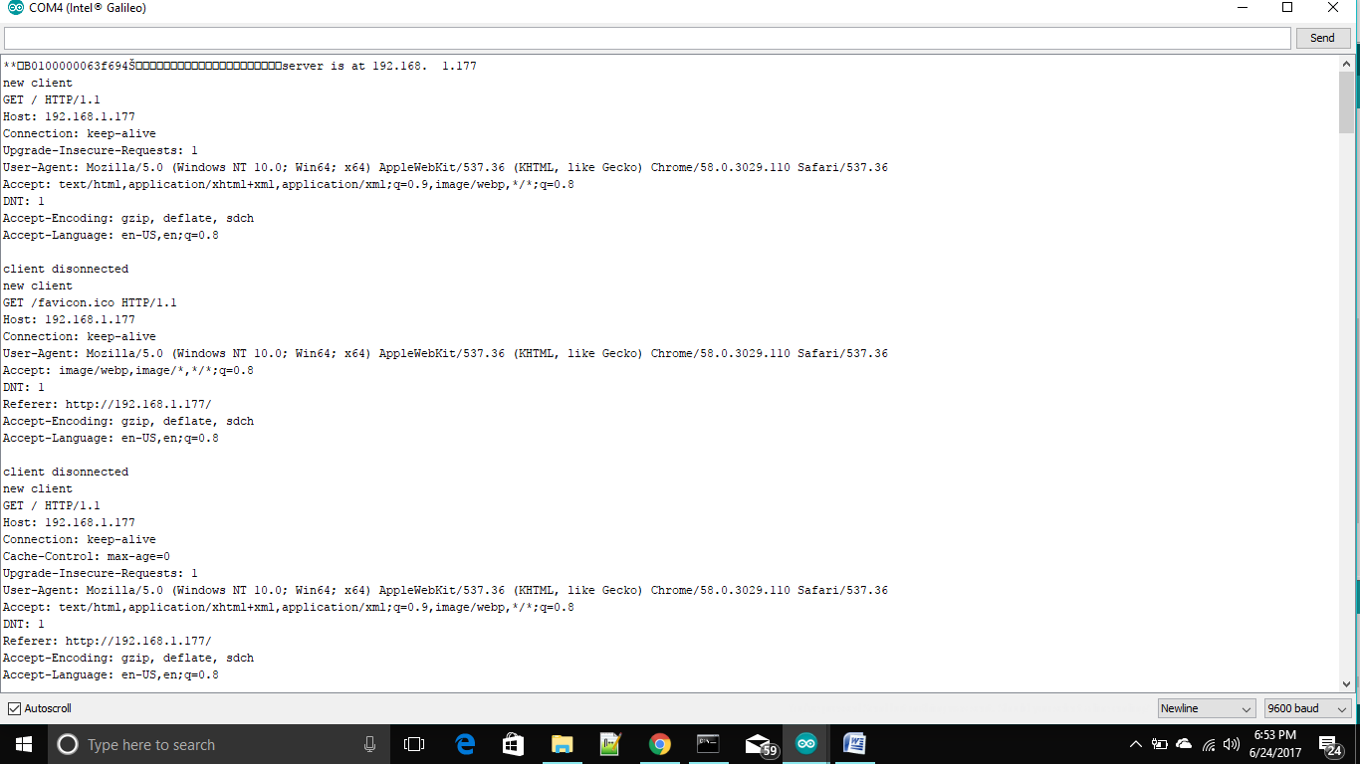

So what I observe is webclient connects to internet and does things while webserver hosts the web service

The thingSpeak that I have observed takes data from iot and stores it on cloud that means in this webclient will be used and data will be saved using url.

Thus in the same way data can be saved anywhere that is in any website that we want to create or we create using url method.

Done thanks

Now lets see if we are able to save data in thingspeak :

Thing speak experiment was successful

In it we have to open and close the client connection each time we have to upload a new data… but still the data upload is not regular on each connection

I think data needs time to upload ;(

In rpi too we are giving sleep of 15 sec………… I really do wonder

**\*\*\*\*You can send data every 15 seconds to ThingSpeak, but most applications work well every minute.\*\*\*\*\*\*\*\*\*\*\*\*\***

<http://community.thingspeak.com/tutorials/arduino/send-data-to-thingspeak-with-arduino/>

*****Thingspeak library is not compatible with intel Galileo gen 2 board

Esp8266 with intel Galileo gen 2

<https://communities.intel.com/message/388073#388073>

It is not possible to use the Galileo Arduino IDE Monitor as a direct way of communication with ESP8266 because the Galileo Arduino IDE monitor is not related to Galileo’s pins 0 & 1 ([Serial ports](https://communities.intel.com/message/220019#220019), [Serial pin 0-1 burned?](https://communities.intel.com/thread/76749)). However, that’s the reason we do not need anything else in Galileo to work on pre-configured 115200 bauds ESP8266 modules (i.e. no extra hardware and no SoftwareSerial library). Adapting the code from <http://allaboutee.com/2014/12/30/esp8266-and-arduino-webserver/> I had in the serial monitor: